ORGANISATIONAL DEVELOPMENT AND CORPORATE SERVICES DIRECTORATE

1. Directorate Overview
  - Financial performance within Organisational Development and Corporate Services is projected to be £0.040 million favourable.

  - For the Directorate as a whole 10 (55%) performance measures are on target with 3 (17%) below target but within tolerance limits and 5 (28%) off target.

  - Risk management is currently reporting no red risks and ten amber risks within the Directorate.

2 Directorate Financial Performance

2.1 The Directorate is currently estimated to have a projected outturn position of £15.393 million against a budget of £15.433 showing a favourable variance of £0.040 million.

Law and Governance
2.2 The service is forecasting an overspend of £0.030 million relating to staffing pressure for a trainee solicitor and maternity leave costs.

Financial Services
2.3 Financial Services is currently forecasting an underspend of £0.070 million which relates to staff turnover within the service.

Treasury Management

2.4 The Base Rate remains at 0.5%. The total investments at the end of the quarter were £82 million at an average rate of return of 1.14%.
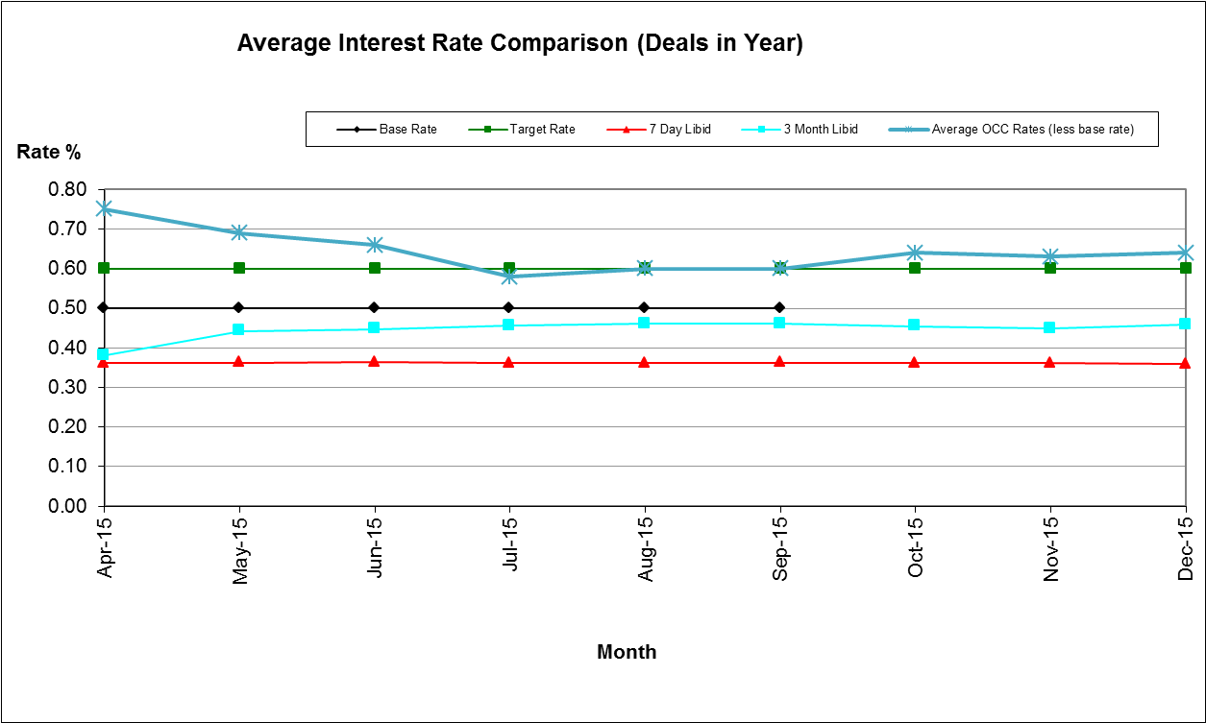

Housing Benefit Overpayments

2.5 The overall value of Housing Benefit Overpayments outstanding rose by £0.124 million over the quarter. The total value of Housing Benefits Overpayments as at 31st December was £6.496 million which is 12.5% higher than the equivalent 12 months previously. This increase is due to the extension of the Real Time Information data matching exercise and the Fraud and Error Incentive Scheme, both of which have increased the levels of fraud and error identification leading to an increase in identified overpayments. Just over £3m of the total outstanding relates to cases where there are currently no arrangements in place to clear the debt, these are subject to review by the end of March 2016, by which time the new Enforcement Agency contract will be in place and static debts will then be reviewed There is sufficient bad debt provision to cover this.

2.6 The benefits service continues to ensure it receives the maximum entitlement to subsidy. It therefore continues to monitor monthly the Local Authority Error and Administration delay figures, to ensure we remain below the lower threshold so that there is no loss in subsidy payments.

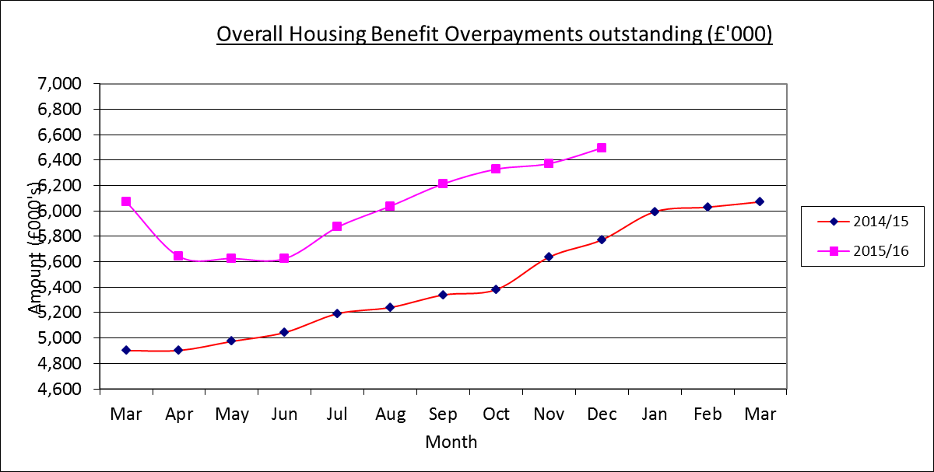

Business Rates

2.7 Arrears of non-domestic rates carried forward on April 1st 2015 were £2.469 million (£0.854 million (25.7%) down on the corresponding figure 12 months earlier.

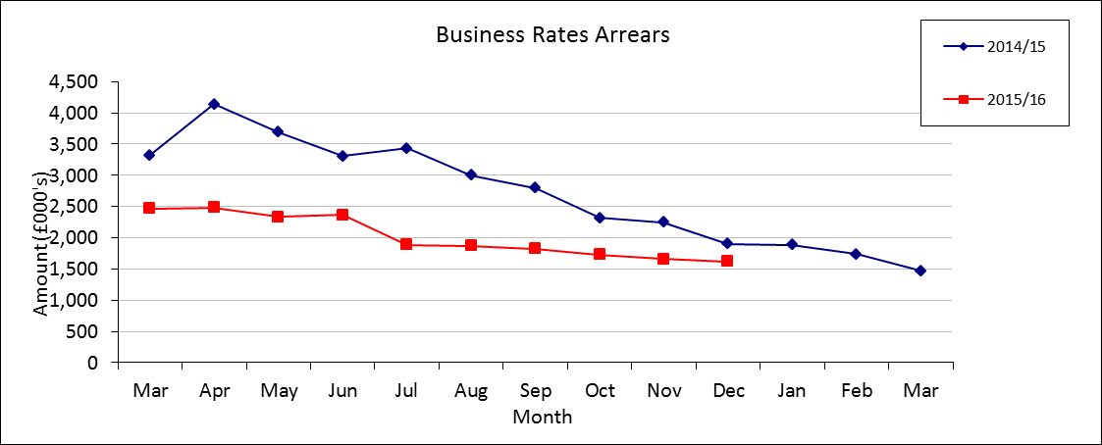

2.8 As at the 31st December arrears had fallen by 34.32% from £1.826 million to £1.621 million. The main reason is the overall collectable debit for prior years has fallen due to Rateable Value deductions. £0.181 million of write offs have also been processed in the current year.

2.9 The 2015/16 collection rate was 84.18% at the end of the quarter against the profiled target of 84%. The collection rate for 2014/15 has moved on from 98.80% at the end of 2014/15 to 99.23% nine months later.

Council Tax Arrears Collection

2.10 Council Tax arrears (i.e. payments due for years 1993-94 up to 2014/15) carried forward on 1st April 2015 were £5.392 million, a 21.4% decrease on the corresponding figure 12 months earlier.
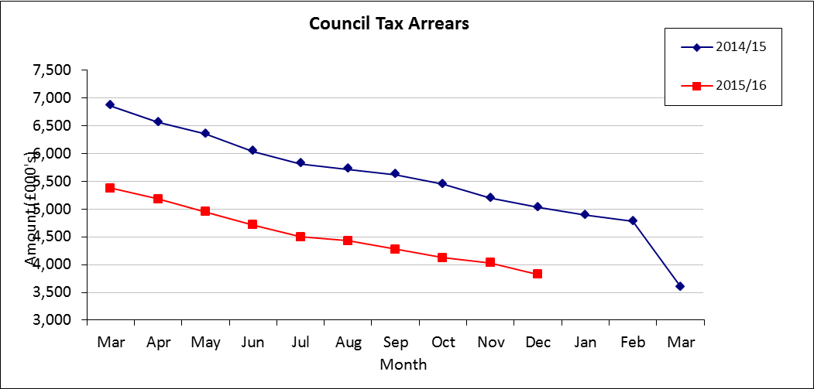

2.11 Over the first three quarters of 2015/16 arrears fell by £1.568 million to £3.824 million, a 23.98% improvement on the level of arrears 12 months before. Payments (net of refunds) received in the first half of the year totalled £1.301 million and write offs of £0.206 million have been processed.

2.12 The collection rate for 2015/16 at the end of the quarter was 85.03%. The corresponding figure 12 months previously was 85.15%. The collection of arrears has exceeded the end of quarter profiled target of 84% by £0.765 million. The collection rate for 2014/15 has moved on from 97.67% at the end of 2014/15 to 98.49% nine months later.

3. Directorate Performance - Exceptions

Business Improvement

3.2 Days lost to sickness – Performance to December 2015 was at 4.95 days across the Council, just above the target of 4.5 days. We are continuing to manage sickness tightly and supporting employees through well-being initiatives. We will focus on the top 3 reasons for absence, which are Infections inc cold/flu; other musculo skeletal & Stomach, liver, kidney & digestion, to see what further improvements can be made.

Organisational Development

3.3 Percentage of employees with a disability – at December 2015, 8.45% of staff were identified as having a disability, against a target of 10%. Numbers remain fairly consistent, with little movement. HR & Payroll will be running a gap analysis in early 2016 around where staff have not reported anything and will look to ensure that data gaps are explained. An analysis of the current data also suggests that some information might be mistakenly uploaded as a disability which might more appropriately be seen as a temporary medical condition which isn’t covered by the Equality Act 2010.

3.4 Percentage of black and ethnic minority employees – the reported figure of 7.8% for December 2015 is the highest for the past five years and represents an increase of 0.7% on the previous year. Despite this, it fell short of our target of 9%. BME application rates are at their highest, averaging 22% for the year to date. HR and Payroll will be looking to follow up all continued data gaps early in 2016 to ensure that staff are reminded to complete their self-declarations.

Financial Services

3.5 Average number of days to manage open tenders – performance at December 2015 was at 185 days against a target of 120 days. This is due to one of the two procurements counted being extended to ensure that the tender evaluation was sufficiently robust.

3.6 Percentage of invoices paid on time –year to date performance at December was 85.4% against a target of 98%. A workshop in January was held to discuss performance and to try to identify how performance can be improved.

3.7 Time to process new benefits claims - performance for December was 15.51 days against a target of 14 days. During December, 252 applications were processed in an average of 8.39 days. This is our best monthly result in 2015/16 to date and the second consecutive when we have been within the challenging target of 14 days. Continued good performance over the next three months will see us close to the 14 day target by year end.

Business Improvement

3.8 Percentage of customers getting through first time on council main lines – year to date performance in December was 93.6% against a target of 95%. There are a number of initiatives in hand to bring this back on target, such as bringing the resilience contract for overflow calls to the contact centre in house from 1st February, increasing the number of CSOs that can work from home and asking part time staff if they would be willing to work additional hours.

3.9 Level of efficiency savings through process improvements – Performance at December 2015 stood at £102,063 against a target of £154,000. Current efficiencies identified (to be achieved this financial year and 2016/17) stands at £297,119. This excludes efficiencies achieved through Admin Review and significant cost avoidance identified through implementation of the new Fraud Detection system.

4. Risk Performance- Exceptions
4.1 There are no red risks in the Directorate but there are 5 amber risks detailed below. All these risks are currently being managed as part of day to day business activity and are not currently expected to rise to a level of red risk.

Business Improvement
4.2 Two amber risks have been identified in this area relating to the volume of ICT projects and not achieving savings targets.

Law and Governance
4.3 One amber risk identified in this area relates to ensuring ICT support is sufficient.

Financial Services
4.4 Two amber risks have been identified in this area relating to failure to recruit and retain key staff, and failure to deliver an efficient and timely year end process for annual Council Tax and NDR bills, Rents, Garage and leaseholder statements.

